# [***81 FR 59551***](https://advance.lexis.com/api/document?collection=administrative-codes&id=urn:contentItem:5KKB-KRY0-006W-838K-00000-00&context=)

Vol. 81, No. 168, Tuesday, August 30, 2016

Proposed Rules

**Reporter**

81 FR 59551 *

***Federal Register* > *2016* > *August* > *Tuesday, August 30, 2016* > *Proposed Rules* > *COMMODITY FUTURES TRADING COMMISSION (CFTC)***

**Title:** **Whistleblower Awards Process**

**Action:**  Notice of proposed rulemaking.

**Agency**

COMMODITY FUTURES TRADING COMMISSION (CFTC)

**Identifier:** **RIN 3038-AE50**

**Administrative Code Citation**

**17 CFR Part 165**

**Synopsis**

**SUMMARY:** The Commodity Futures Trading Commission ("Commission" or "CFTC") is proposing to amend its ***regulations*** to enhance the process for reviewing whistleblower claims and to make related changes to clarify staff authority to administer the whistleblower program. The Commission also is reinterpreting its anti-retaliation authority and proposing appropriate rule amendments to implement that authority.

**Text**

**SUPPLEMENTARY INFORMATION:** In 2011, the Commission adopted its part 165 ***regulations***, which implement section 23 of the Commodity Exchange Act ("CEA"), [*7 U.S.C. 26*](https://advance.lexis.com/api/document?collection=statutes-legislation&id=urn:contentItem:4YF7-GT91-NRF4-40PG-00000-00&context=), by establishing a regulatory framework for the whistleblower program. *See* Whistleblower Incentives and Protection, [*76 FR 53172*](https://advance.lexis.com/api/document?collection=administrative-codes&id=urn:contentItem:53MN-T5F0-006W-81BF-00000-00&context=) (August 25, 2011). Part 165 provides for the payment of awards, subject to certain limitations and conditions, to whistleblowers who voluntarily provide the Commission with original information about a violation of the CEA that leads to the successful enforcement of an action brought by the Commission that results in monetary sanctions exceeding $ 1,000,000 ("Covered Action"), or the successful enforcement of a related action, as that term is defined in the rules, or both.

The award amount must be between 10 and 30 percent of the amount of monetary sanctions collected in a Covered Action or a related action and is paid from the CFTC Customer Protection Fund. The Commission has discretion regarding the amount of an award based on the significance of the information, the degree of assistance provided by the whistleblower, and other criteria.

Since the whistleblower program was established in 2011, the need for certain improvements has become apparent. As explained further below, this rulemaking proposal addresses that need with targeted revisions to the claims review process and to the authority of staff to administer the whistleblower program. The Commission also is reinterpreting its anti-retaliation authority under CEA section 23(h)(1) and proposing rule amendments to implement that authority. Finally, the Commission is proposing to amend its rules to permit whistleblowers to receive awards based on both Covered Actions and the successful enforcement of related actions, as defined in the rules.

**II. Proposed Amendments**

The Commission proposes to make targeted changes to the process for reviewing whistleblower award claims. In considering what changes to make, the Commission has been informed by its experience since the inception of its program, as well as the experience of the Securities and Exchange Commission ("SEC") in the administration of its whistleblower program. In many ways, the SEC program is similar to the Commission's. Both were created under the Dodd-Frank Act, n1 although the SEC also had prior experience in administering its insider trading bounty program. n2 The Commission believes that these proposed amendments will, among other things, significantly improve the administration of its review process.

n1 Section 922 of the Dodd-Frank Act amended the Securities Exchange Act of 1934 by adding section 21F, which provides for the SEC's whistleblower program. Similar to the CFTC program, the SEC program authorizes monetary awards to eligible individuals who voluntarily provide original information that leads to successful SEC enforcement actions resulting in the imposition of monetary sanctions over $ 1,000,000 and certain related successful actions. The SEC can make awards ranging from 10 to 30 percent of the monetary sanctions collected, which are paid from its Investor Protection Fund.

Section 924(d) of the Dodd-Frank Act directed the SEC to establish a separate office to administer the whistleblower program. In February 2011, the SEC established the Office of the Whistleblower within the Division of Enforcement to carry out this mandate.

n2 This SEC program was established in 1989 under Section 21A(e) of the Securities Exchange Act of 1934, which authorized the SEC to award a bounty to a person who provided information leading to the recovery of a civil penalty from an insider trader or related parties. Section 21A(e) was enacted in 1988 as part of the Insider Trading and Securities Fraud Enforcement Act of 1988 and was repealed in 2010 by section 923(b) of the Dodd-Frank Act.

The SEC abolished its bounty program when it established its whistleblower program under the Dodd-Frank Act.

*Eligibility Requirements for Consideration of an Award*

Currently, § 165.5 specifies the requirements for consideration of an award by the Commission. The Commission proposes to revise this rule to make clear that a claimant may receive an award in a Covered Action, in a related action, or both. The Commission also proposes to make clear that a claimant may be eligible for an award by providing the Commission original information without being the original source of the information. In addition, based on its experience in administering the whistleblower program, the Commission proposes to revise the definition of "original source" in § 165.2(l) to extend the timeframe from 120 to 180 days that a whistleblower has to file a Form TCR pursuant to § 165.3 after previously providing the same information to Congress, any other federal or state authority, a registered entity, a registered futures association, a self-regulatory organization, or to any of the persons described in § 165.2(g)(4) and (5). Finally, in § 165.5(c), the Commission is providing notice that it has discretion to waive procedural rules based upon a showing of extraordinary circumstances.

*Award Claims Review Under § 165.7*

Currently, § 165.7(d) provides for the review of whistleblower award claims. The Commission proposes to revise this rule in order to better define and specify each step in the award review process. Those steps are spelled out in proposed new paragraphs (f) through (l), along with new provisions regarding withdrawing award applications in **[*59553]** proposed paragraph (d) and disposition of claims that do not relate to Notices of Covered Actions ("NCAs") or final judgments in related actions in proposed new paragraph (e). These amendments would establish a review process similar to that established under the SEC's whistleblower rules. *See* [*17 CFR 240.21F-10(d)*](https://advance.lexis.com/api/document?collection=administrative-codes&id=urn:contentItem:5NBM-FN10-008G-Y158-00000-00&context=) through (h) (2014). Specifically, the Commission has proposed to discontinue the Whistleblower Award Determination Panel and replace it with a review process handled by a Claims Review Staff designated by the Director of the Division of Enforcement in consultation with the Executive Director. n3 The Commission expects that the Claims Review Staff will be assisted by the Whistleblower Office staff within the Division of Enforcement. n4 The proposed rules also provide an additional means for the submission of the required Form WB-APP, Application for Award for Original Information Provided Pursuant to section 23 of the Commodity Exchange Act, in § 165.7(b)(1); explain the deadline for filing Form WB-APP under different timing scenarios for final judgments in covered judicial or administrative actions and related actions in proposed § 165.7(b)(3); and, make a conforming change by renumbering prior paragraph (e) in § 165.7 as paragraph (l).

n3 Designation and composition of the Claims Review Staff is described in proposed § 165.15(a)(2).

n4 The Commission expects that the Whistleblower Office will provide assistance to the Claims Review Staff in the form of analysis of a claimant's eligibility and, if applicable, a recommendation of a proposed award amount. Any such assistance provided by the Whistleblower Office to the Claims Review Staff will be prepared exclusively to assist the Claims Review Staff in deciding a claim and will be deliberative process materials that will not be available to claimants under § 165.10 or part of the record on appeal under § 165.13. The proposed rules contain clarifying changes to these rules.

New proposed § 165.7(e) addresses the Commission's experience of receiving a number of Form WB-APPs that appear to be unrelated to NCAs or final judgments in related actions as well as Form WB-APPs that do not relate to a previously filed Form TCR. In order to reduce the administrative burden on the Commission, the Commission proposes that such facially ineligible claims primarily be handled by the Whistleblower Office. The Whistleblower Office will notify the claimant of the deficiencies in the Form WB-APP and provide an opportunity for the claimant to correct the deficiencies or withdraw the claim before the finalization of the denial of the claim. If the claimant does not correct the deficiencies or withdraw the claim, the Whistleblower Office will notify the Claims Review Staff of the proposed denial, which will be called a Proposed Final Disposition, and any member of the Claims Review Staff will have the opportunity to request review of the proposed denial. If no member of the Claims Review Staff requests review, the Proposed Final Disposition will become the final order of the Commission. If a member of the Claims Review Staff requests review, the Claims Review Staff will review the record for the denial and either remand to the Whistleblower Office for further action or issue a final order of the Commission, which consists of the proposed denial. Additionally, proposed § 165.7(d) would permit a claimant to withdraw an award application at any point in the review process by submitting a written request to the Whistleblower Office. n5

n5 A claimant may choose to withdraw a claim for any reason including that it was filed erroneously. An example would be if a claimant intended to submit a tip via a Form TCR but mistakenly submitted a claim via a WB-APP. The proposed addition to § 165.7(d) would allow the claimant to withdraw the WB-APP and file a Form TCR.

Under proposed § 165.7(f), n6 the Claims Review Staff will evaluate all timely award applications submitted on a Form WB-APP in response to the NCA or a final judgment in a related action. n7 During the review process, the Whistleblower Office may require that claimants provide additional information, explanation, or assistance as set forth in § 165.5(b)(3). For award claims on related actions, as described in § 165.7(f), the Whistleblower Office may request additional information from the claimant to demonstrate that the claimant voluntarily provided the governmental agency, regulatory authority, or self-regulatory organization the same original information that led to the Commission's successful enforcement action and the successful enforcement of the related action. The Whistleblower Office may also seek assistance and confirmation from the other agency in making this determination.

n6 Proposed § 165.7(f) is a revised version of current § 165.7(d).

n7 The Whistleblower Office will not post any notices for related actions. It will be the claimant's responsibility to track the progress and final resolution of any related action and to file a claim with the Commission under § 165.7(b).

Under proposed § 165.7(g)(1), following the initial evaluation by the Claims Review Staff, the Claims Review Staff will issue a Preliminary Determination setting forth a preliminary assessment as to whether the claim should be granted or denied and, if granted, setting forth the proposed award percentage amount. The Whistleblower Office will send a copy of the Preliminary Determination to the claimant. The proposed amendments would allow a claimant the opportunity to contest the Preliminary Determination. n8

n8 If a claimant has no objection to the Preliminary Determination, the claimant could inform the Whistleblower Office of the decision not to contest within the 60 calendar days after issuance of the Preliminary Determination. This situation might occur when the Preliminary Determination recommends an award and the claimant has no objection to the recommended amount of the award.

Under new proposed § 165.7(g)(2), the claimant could take any of the following steps in response to a Preliminary Determination:

* Within thirty (30) calendar days of the date of the Preliminary Determination, the claimant may request that the Whistleblower Office make available for the claimant's review the materials that formed the basis of the Claim Review Staff's Preliminary Determination.

1. Within sixty (60) calendar days of the date of the Preliminary Determination, or if a request to review materials is made, then within sixty (60) days of the Whistleblower Office making those materials available for the claimant's review, a claimant may submit a written response setting forth the grounds for the claimant's objection to either the denial of an award or the proposed amount of an award. The claimant may also include documentation or other evidentiary support for the grounds advanced in any response, and request a meeting with the Whistleblower Office. However, such meetings would not be required. The Whistleblower Office may in its sole discretion decline the request.

New proposed § 165.7(h) makes clear that if a claimant fails to submit a timely response under new § 165.7(g), then a Preliminary Determination denying an award becomes the Final Order of the Commission and constitutes a failure to exhaust the claimant's administrative remedies. n9 Failure to exhaust administrative remedies would prohibit the claimant from pursuing judicial review.

n9 Pursuant to § 165.7(l), the Office of the Secretariat will serve on the claimant a copy of the Final Order.

If the claimant fails to contest a Preliminary Determination recommending an award, the Preliminary Determination would be treated as a Proposed Final Determination, which would make it subject to Commission review under proposed § 165.7(j).

New § 165.7(i) describes the procedure in cases where a claimant submits a timely response under new **[*59554]** § 165.7(g). In such cases, the Claims Review Staff would consider the issues raised in the claimant's response, along with any supporting documentation that the claimant provides, and prepare a Proposed Final Determination.

Under new § 165.7(j), when there is a Proposed Final Determination, the Whistleblower Office will notify the Commission of the Proposed Final Determination. Within thirty (30) days of that notification, any Commissioner may request Commission review of the Proposed Final Determination. If no Commissioner makes such a request, the Proposed Final Determination will become the Commission's Final Order. If a Commissioner does request review, the Commission will review the record that the Claims Review Staff relied upon in reaching its determination. On the basis of its review of that record, the Commission will issue its Final Order, which the Office of the Secretariat will then serve on the claimant. In reaching their decisions, the Commission and Claims Review Staff will only consider information in the record.

The Office of General Counsel will review both preliminary and proposed final determinations prior to issuance, and no such determination may be issued without the Office of General Counsel's determination of legal sufficiency.

Under proposed § 165.15(a)(2), the Enforcement Director, in consultation with the Executive Director, will designate a minimum of three and a maximum of five staff from the Division of Enforcement or other Commission Offices or Divisions to serve on the Claims Review Staff, either on a case-by-case basis or for fixed periods. At least one person from outside the Division of Enforcement will be included on the Claims Review Staff at all times. The Claims Review Staff would be composed only of persons who have not had direct involvement with the underlying enforcement action. Due to the Office of General Counsel's role in the review process, the Commission believes it is appropriate to exclude staff from that Office from serving as Claims Review Staff.

These proposed amendments would provide the public and claimants with greater transparency in the award evaluation and review process. They should also enhance the expeditious and fair administration of the program.

*Awards for Related Actions*

For award claims on related actions, the Commission is proposing to amend § 165.11 to permit claimants who are eligible to receive an award in a covered judicial or administrative action also to receive an award based on the monetary sanctions that are collected from a final judgment in a related action. The exception would be that the Commission would not make an award to a claimant for a related action if the claimant had been granted an award by the SEC for the same action under the SEC's whistleblower program. This would prevent a claimant from "double dipping" and receiving more than one award for the same action. Similarly, if the SEC has previously denied an award to a claimant in a related action, the claimant will be precluded from relitigating any issues before the Commission that the SEC resolved against the claimant as part of the SEC's award denial. These limitations on obtaining an award for both Covered Actions and final judgments in related actions are similar to those imposed by the SEC in its whistleblower program.

Pursuant to the definition of related action in § 165.2(m), a related action is based on the original information voluntarily submitted by a whistleblower to the Commission that led to the successful enforcement of a Commission action, and therefore, an action may only become a "related action" after there is a successful Commission action. Additional revisions are proposed to § 165.7(b) to clarify timing requirements for filing whistleblower award claims regarding related actions. The proposed revisions also clarify that except in the circumstances described in proposed § 165.7(b)(3)(ii), award claims for a related action shall be filed within 90 days after an action meets the definition of related action if the order in the related action was issued prior to the successful enforcement of a Commission action. The proposed revisions also clarify that award claims for a related action and in response to a Notice of Covered Action may be submitted on the same Form WB-APP in certain circumstances.

*Contents of Record for Award Determinations*

Consistent with the Commission proposing to amend § 165.11 to permit claimants who are eligible to receive an award in a covered judicial or administrative action also to receive an award based on the monetary sanctions that are collected from a final judgment in a related action, the Commission proposes to amend § 165.10(a) to include additional items that may be included in the contents of record for award claims. For related actions, any documents or materials, including sworn declarations from third parties, that are received or obtained by the Whistleblower Office to assist the Commission in resolving the claimant's award application, including information relating to the claimant's eligibility, may be included in the record. In addition, any information provided to the Commission by the entity bringing the related action that has been authorized by the entity for sharing with the claimant may be part of the record. Neither of these forms of information may be included in the contents of the record if the entity did not authorize the Commission to share the information with the claimant. The Commission also proposes revisions to §§ 165.10(b) and 165.13(b) to clarify that the record on appeal shall not include any pre-decisional or internal deliberative process materials that are prepared to assist the Commission or Claims Review Staff in deciding a claim.

*Authority To Administer the Program*

Currently, § 165.15 provides for delegations of authority to the staff. Given the proposed changes to the claims review process, the Commission proposes to directly assign responsibilities for administering the program by rule rather than by delegation. Since 2013, the Whistleblower Office ("WBO") has been located within the Division of Enforcement. The Commission believes that it is appropriate to assign overall responsibility for administering the whistleblower program to the Director of the Division of Enforcement. The Commission notes that this approach is also consistent with the SEC's practice.

The Commission also proposes to directly assign responsibility to Claims Review Staff for the issuance of Preliminary Determinations and Proposed Final Determinations, and issuance of Proposed Final Dispositions to the WBO. In this connection, the Commission proposes, again consistent with the SEC's practice, that no member of the Claims Review Staff can have had any direct involvement in the underlying enforcement case.

*Whistleblower Identifying Information*

To implement the confidentiality protection for whistleblower identifying information under CEA section 23(h)(2), the Commission issued § 165.4. The Commission is proposing to authorize the Director of the Division of Enforcement to act on its behalf to disclose whistleblower identifying information as permitted by CEA section 23(h)(2)(C) and § 165.4(a)(2) and (3). Under § 165.15(a)(3), the Commission expects the Director of Enforcement to exercise this discretion to release such sensitive information in **[*59555]** a manner consistent with, and when deemed necessary or appropriate to accomplish, the customer protection and law enforcement goals of the whistleblower program. n10 The Commission believes that this delegation of authority will increase investor protection by facilitating administration of the whistleblower program as well as investigations and actions by those agencies and authorities that are eligible to receive whistleblower identifying information under CEA section 23(h)(2)(C) and § 165.4. Any agency or authority that receives whistleblower identifying information is bound by the same confidentiality requirements as those applicable to the Commission under CEA section 23(h)(2)(A) and such release of information does not change the confidential nature of the information. Certain information provided to other agencies or authorities is also protected from disclosure under CEA section 8.

n10 Whistleblower Incentives and Protection, 76 FR at 53184 (Aug. 25, 2011) (declining to require whistleblower notification).

*Retaliation Against Whistleblowers*

During its 2011 rulemaking, the Commission was asked to clarify its enforcement authority over retaliation against whistleblowers. Citing the private right of action for whistleblowers created by CEA section 23(h)(1)(B), the Commission stated that it lacked "the statutory authority to conclude that any entity that retaliates against a whistleblower" could be subject to enforcement action "as a separate and independent violation of the CEA." Whistleblower Incentives and Protection, 76 FR at 53182 (August 25, 2011). The Commission stated that CEA section 23(h)(1)(B)(i) "clearly states only an individual who alleges retaliation in violation of being a whistleblower may bring such a cause of action." *Id.*

Questions have been raised, however, about the inconsistency between this interpretation and the SEC's interpretation of its own authority to take enforcement actions against violators of the anti-retaliation provisions of the SEC's whistleblower protection rules. Accordingly, the Commission is revisiting this issue. The Commission proposes to set aside its 2011 interpretation because it fails to adequately take into full consideration the statutory context of CEA section 23 and other CEA provisions. The 2011 interpretation cannot be squared with CEA section 23(h)(1)(A), which establishes that retaliation is in fact a separate violation of the CEA, nor with the Commission's broad rulemaking authority under CEA section 23(i). The 2011 interpretation also overlooks the Commission's general authority to prosecute violations of any CEA provisions as well as violations of the Commission's rules and orders under CEA sections 6(c), 6(d), 6b, and 6c. Each of these CEA sections empowers the Commission to take action for the violation of "any" CEA provision or rule or ***regulation*** thereunder. The Commission notes that while CEA section 23(h)(1) provides for enforcement of the anti-retaliation provisions through a private cause of action, nothing in that section purports to limit the Commission's general enforcement authority or suggests that such private action is exclusive. The SEC's statutory authority in this area is nearly identical to the Commission's, and that agency took a different path in 2011. When commenters asked the SEC to clarify protections against retaliation, it did so by adopting a rule that made any rules promulgated under the protections against retaliation provisions enforceable in an action or proceeding brought by the SEC. n11 Upon reconsideration of its statutory authority on this important issue, and noting that harmonization between the SEC's and the Commission's Whistleblower programs would be beneficial to the public by making the consequences of illegal retaliation more uniform, the Commission has decided to join the SEC on that path.

n11 *See* SEC Rule 21F-2(b) ([*17 CFR 240.21F-2(b)*](https://advance.lexis.com/api/document?collection=administrative-codes&id=urn:contentItem:5NH3-PNM0-008G-Y4F5-00000-00&context=)).

By today's action, the Commission is taking a necessary step to end the incongruous situation where whistleblowers enjoy protection from retaliation through SEC enforcement action under the securities laws, but no such protection through Commission enforcement action under the CEA. In 1982, Congress granted customers a private right of action under CEA section 22 without diminishing or undermining the Commission's enforcement authority under the CEA. So too here, the Commission believes that Congress intended the Commission to fully exercise its enforcement authority with respect to CEA section 23(h)(1)(A) and to fully exercise its rulemaking authority under CEA section 23(i) in addition to creating a private right of action to protect whistleblowers.

The Commission's proposal also removes any question about a gap in statutory whistleblower protection under the securities laws and the CEA. Consistent with the SEC's approach in its rule, the Commission proposes to add new § 165.20(b) to implement its enforcement authority under CEA section 23 and 17 CFR part 165. To complement the prohibition found in CEA section 23(h)(1)(A), and as consistent with the SEC's whistleblower rules, the Commission proposes to add a new § 165.19(b) to prohibit the enforcement of confidentiality and pre-dispute arbitration clauses respecting actions by potential whistleblowers in any pre-employment, employment or post-employment agreements, n12 and a new § 165.20(a) and (c) to prohibit employers from threatening or harassing or retaliating against individuals who participate in the Commission's whistleblower program, irrespective of whether those individuals qualify for an award, n13 or report internally before providing the Commission with information. n14 The Commission believes that these proposed rules are appropriate to implement CEA section 23(h)(1) and are fully consistent with the purposes of that provision as required by CEA section 23(i).

n12 The Commission is aware of the SEC's enforcement action against the use of confidentiality agreements that might interrupt the free flow of communications from whistleblowers to enforcement authorities. *See In the Matter of KBR Inc.,* SEC Admin. Proc. No. 3-16446 (April 1, 2015) (barring KBR from requiring its employees to have internal clearance before communicating with the SEC on whistleblower matters).

n13 The concept of a whistleblower being protected from retaliation by an employer irrespective of whether the whistleblower qualified for an award is expressed in the definition of whistleblower in § 165.2(p)(2). The Commission is providing whistleblowers additional protections in new § 165.20(a) and (b), and adding § 165.20(c) for convenience and clarity.

n14 The Commission is aware of the SEC's recent Interpretation of the SEC's Whistleblower Rules Under Section 21F of the Securities Exchange Act of 1934, Release No. 34-75592 (August 4, 2015), in which the SEC similarly clarified that anti-retaliation protections extended to individuals who reported internally prior to providing the SEC with information and to individuals who ultimately were not eligible for an award.

*Conforming and Technical Amendments*

To conform to the proposed changes to §§ 165.7 and 165.15, the Commission proposes to strike the reference to "or its delegate" in § 165.11 in the undesignated material before paragraph (a).

The Commission proposes to amend § 165.2(i)(2) concerning the definition of information that led to a successful enforcement action because it contains an erroneous cross-reference. The reference is intended to be to § 165.2(l) regarding the definition of original source. The rule currently refers to paragraph (i) of the section.

The Commission proposes to make a minor change to the wording of § 165.3 concerning the procedures for **[*59556]** submitting original information because it contains an erroneous reference to a two-step process. This change makes the language conform to the process previously adopted. n15

n15 *Whistleblower Incentives and Protection,* 76 FR at 53183 (Aug. 25, 2011) (explaining that the rule was adopted with a more streamlined process and one less form than the original proposal).

The Commission proposes to amend § 165.13(b) concerning appeals because it contains an erroneous cross-reference. The reference intended is to § 165.10 regarding contents of the record, rather than § 165.9 regarding criteria for determining award amounts.

The Commission proposes to move and include updated Form TCR and Form WB-APP to a new appendix B to part 165. The updated Form TCR and Form WB-APP include revisions that previously received information collection requirement approval by the Office of Management and Budget. n16 The Commission also proposes to revise a question in the Form TCR, question E.8, seeking consent from whistleblowers to share their information with other authorities. The revisions include language that is consistent with the confidentiality provisions of § 165.4. The Commission also proposes revisions to the submission instructions portions of the forms to conform to the proposed revisions in the part 165 rules.

n16 The Form TCR and Form WB-APP OMB Control Number is 3038-0082. Both forms last received OMB approval on April 8, 2015, with an expiration date of April 30, 2018.

Finally, the Commission proposes to make a minor change in the wording of current § 165.7(e), in addition to designating current paragraph (e) as new paragraph (l).

**III. Request for Comment**

The Commission requests comment on all aspects of the proposed rule amendments.

**IV. Related Matters**

*A. Regulatory Flexibility Analysis*

The Regulatory Flexibility Act ("RFA"), *5 U.S.C. 601*-612, requires that agencies consider whether the rules they propose will have a significant economic impact on a substantial number of small entities and, if so, provide a regulatory flexibility analysis respecting the impact. RFA section 603(a), *5 U.S.C. 603(a)*, requires the Commission to undertake an initial regulatory flexibility analysis of a proposed rule on small entities unless the Chairman certifies that the rule, if adopted, would not have a significant economic impact on a substantial number of small entities. *5 U.S.C. 605(b)*.

Only individuals are eligible for participation in the Commission's whistleblower program. The proposed amendments would apply only to an individual, or individuals acting jointly, who provide information relating to the violation of the CEA or Commission ***regulations***. By definition, companies and other entities cannot be whistleblowers. Consequently, the persons that would be subject to the proposed rule amendments are not "small entities" under the RFA.

Accordingly, the Chairman, on behalf of the Commission, hereby certifies under *5 U.S.C. 605(b)* that the proposed rules would not have a significant economic impact on a substantial number of small entities.

*B. Paperwork Reduction Act*

The Paperwork Reduction Act ("PRA"), [*44 U.S.C. 3501*](https://advance.lexis.com/api/document?collection=statutes-legislation&id=urn:contentItem:4YF7-GNM1-NRF4-408K-00000-00&context=)-[*3521*](https://advance.lexis.com/api/document?collection=statutes-legislation&id=urn:contentItem:4YF7-GWR1-NRF4-43SN-00000-00&context=), imposes certain requirements on federal agencies (including the Commission) in connection with their conducting or sponsoring any collection of information as defined by the PRA. The Commission believes that the proposed amendments, if adopted, would not impose new recordkeeping or information collection requirements that require approval by the Office of Management and Budget under the PRA.

Accordingly, the requirements of the PRA do not apply to this rulemaking.

*C. Cost-Benefit Considerations*

CEA section 15(a) requires the Commission to consider the costs and benefits of its actions before promulgating a ***regulation*** under the CEA or issuing certain orders. n17 Section 15(a) further specifies that the costs and benefits shall be evaluated in light of the following five factors: (1) Protection of market participants and the public; (2) efficiency, ***competitiveness***, and financial integrity of futures markets; (3) price discovery; (4) sound risk management practices; and (5) other public interest considerations. The Commission considers the costs and benefits resulting from its discretionary determinations with respect to the section 15(a) factors. The Commission may in its discretion give greater weight to any one of the five enumerated areas and could in its discretion determine that, notwithstanding its costs, a particular rule is necessary or appropriate to protect the public interest or to effectuate any of the provisions or accomplish any of the purposes of the CEA.

n17 [*7 U.S.C. 19(a)*](https://advance.lexis.com/api/document?collection=statutes-legislation&id=urn:contentItem:4YF7-GRD1-NRF4-42KS-00000-00&context=).

Since the basic framework of part 165 remains substantially unchanged, the Commission believes that the costs and benefits of the proposed rule amendments and the status quo baseline (the current rule), to which the proposal's costs and benefits are compared, are similar, but with certain additional benefits attendant to these amendments. n18 The § 165.7 amendments would add transparency to the Commission's process of deciding whistleblower award claims and would harmonize the Commission's rules with those of the SEC. The proposed amendments clarify each step of the process that a whistleblower must follow when making an award claim. The Commission believes that such transparency and harmonization would increase the benefits of the part 165 rules relative to the benefits of the current rules because potential whistleblowers would have greater clarity about the claims and awards process and greater assurance that retaliation would not be tolerated. This clarity and protection should encourage whistleblowers to step forward. Thus, the proposed rules should enhance protection of market participants and the public as well as market integrity without materially adding to the costs attendant to the current regime.

n18 The Commission preliminarily believes that there is not likely to be any material difference between the proposed amendments and the status quo baseline in terms of cost.

The § 165.4 and 165.15 amendments assign to the Director of the Division of Enforcement the authority to administer the whistleblower program and release whistleblower identifying information. Since these proposed amendments relate solely to the Commission's allocation of authority among its staff, the Commission anticipates that these changes would impose no material costs on market participants or the public. At the same time, the Commission believes the protection of market participants and the public would be enhanced through a more effective and efficient deployment of staff resources.

The § 165.19 and 165.20 amendments clarify the anti-retaliation protections available under the Commission's whistleblower program in light of the Commission's reconsideration of its authority under CEA section 23(h)(1). These proposed changes remove any gap in enforcement authority between the Commission and the SEC with regard to whistleblower protections against retaliation. The Commission preliminarily believes that these **[*59557]** changes would impose no material costs on market participants or the public. The proposed rules do not impose any new regulatory burden. To comply with the rules, market participants must refrain from engaging in conduct that is already subject to private rights of action, or including certain provisions waiving rights and remedies or requiring arbitration of disputes in employment agreements. The Commission further believes that the proposed rules might have a positive effect on efficiency, ***competitiveness***, and financial integrity of futures markets through improving detection and remediation of potential violations of the CEA and Commission ***regulations***. For instance, market participants may be further deterred from engaging in violations of the CEA and Commission rules because the likelihood of being caught has increased due to improvements to the whistleblower program that encourage more whistleblowers to provide information to the Commission.

The Commission preliminarily believes that price discovery and sound risk management practices would not be materially affected by this proposal. Also, the Commission has not identified any other relevant public interest considerations.

The Commission invites public comment on its cost-benefit considerations. Commenters are also invited to submit any data or other information that they may have quantifying or qualifying the costs and benefits of the proposed rules.

*D.* ***Antitrust*** *Considerations*

CEA section 15(b) requires the Commission to consider the public interests protected by the ***antitrust*** laws and to take actions involving the least anti-***competitive*** means of achieving the objectives of the CEA. The Commission preliminarily believes that the proposed rules may have a positive effect on ***competition*** through improving detection, deterrence, and remediation of potential violations of the CEA and Commission ***regulations***.

The Commission invites comment on any ***antitrust*** considerations arising from the proposed amendments.

*E. Small Business Regulatory Enforcement Fairness Act*

Under the Small Business Regulatory Enforcement Fairness Act of 1996 ("SBREFA"), *Public Law 104-121* (March 29, 1996), as amended by *Public Law 110-28* (May 25, 2007), n19 the Commission solicits data to determine whether a proposed rule constitutes a "major" rule. Under SBREFA, a rule is considered "major" where, if adopted, it results or is likely to result in:

n19 The provisions governing congressional review of agency rulemaking are set forth in SBREFA subtitle E, which is codified at *5 U.S.C. 801*-808.

* An annual effect on the economy of $ 100 million or more (either in the form of an increase or a decrease);

1. A major increase in costs or prices for consumers or individual industries; or
2. Significant adverse effects on ***competition***, investment or innovation.

If a rule is "major," its effectiveness will generally be delayed for 60 days pending Congressional review.

Commenters are invited to provide empirical data on: the potential annual effect on the economy; any increase in costs or prices for consumers or individual industries; and any potential effect on ***competition***, investment or innovation.

***Regulations***

**List of Subjects in 17 CFR Part 165**

Whistleblowing.

For the reasons stated in the preamble, the Commodity Futures Trading Commission proposes to amend 17 CFR part 165 as follows:

1. The authority citation for part 165 continues to read as follows:

**Authority:** [*7 U.S.C. 2*](https://advance.lexis.com/api/document?collection=statutes-legislation&id=urn:contentItem:4YF7-GJ91-NRF4-44CM-00000-00&context=), [*5*](https://advance.lexis.com/api/document?collection=statutes-legislation&id=urn:contentItem:4YF7-GNY1-NRF4-43SJ-00000-00&context=), [*12a(5)*](https://advance.lexis.com/api/document?collection=statutes-legislation&id=urn:contentItem:4YF7-GHK1-NRF4-42DD-00000-00&context=) and [*26*](https://advance.lexis.com/api/document?collection=statutes-legislation&id=urn:contentItem:4YF7-GT91-NRF4-40PG-00000-00&context=), as amended by Title VII of the Dodd-Frank Wall Street Reform and Consumer Protection Act, *Pub. L. 111-203*, *124 Stat. 1376* (July 16, 2010).

1. In § 165.2, revise paragraphs (i)(2) and (l)(2) to read as follows:

*    *    *    *    *

1. * * *
2. The whistleblower gave the Commission original information about conduct that was already under examination or investigation by the Commission, the Congress, any other authority of the federal government, a state Attorney General or securities regulatory authority, any self-regulatory organization or futures association, or the Public Company Accounting Oversight Board (except in cases where the whistleblower was an original source of this information as defined in paragraph (l) of this section), and the whistleblower's submission significantly contributed to the success of the action.

   *    *    *    *    *

1. * * *
2. ***to another authority or person.***If the whistleblower provides information to Congress, any other federal or state authority, a registered entity, a registered futures association, a self-regulatory organization, or to any of any of the persons described in paragraphs (g)(4) and (5) of this section, and the whistleblower, within 180 days, makes a submission to the Commission pursuant to § 165.3, as the whistleblower must do in order for the whistleblower to be eligible to be considered for an award, then, for purposes of evaluating the whistleblower's claim to an award under § 165.7, the Commission will consider that the whistleblower provided original information as of the date of the whistleblower's original disclosure, report, or submission to one of these other authorities or persons. The whistleblower must establish the whistleblower's status as the original source of such information, as well as the effective date of any prior disclosure, report, or submission, to the Commission's satisfaction. The Commission may seek assistance and confirmation from the other authority or person in making this determination.

   *    *    *    *    *

1. Amend § 165.3 as follows:
2. Remove the undesignated introductory paragraph; and
3. Revise the introductory text of paragraph (a), and paragraph (a)(1).

The revisions to read as follows:

1. **ing original information.**
2. A whistleblower will need to submit the whistleblower's information to the Commission. A whistleblower may submit the whistleblower's information:
3. By completing and submitting a Form TCR online and submitting it electronically through the Commission's Web site at [*www.cftc.gov*](http://www.cftc.gov)*,* or the Commission's Whistleblower Program Web site at [*www.whistleblower.gov*](http://www.whistleblower.gov)*;* or

   *    *    *    *    *

1. In § 165.4, revise the introductory text of paragraph (a), and paragraphs (a)(1) and (2) to read as follows:
2. Section 23(h)(2) of the Commodity Exchange Act requires that the Commission not disclose information that could reasonably be expected to reveal the identity of a whistleblower, except that the Commission may disclose such information in the following **[*59558]** circumstances, in accordance with the Privacy Act of 1974 (*5 U.S.C. 552a*):
3. When disclosure is required to a defendant or respondent in connection with a public proceeding that the Commission institutes or in another public proceeding that is filed by an authority to which the Commission provides the information, as described below; or
4. When the Commission determines that it is necessary to accomplish the purposes of the Commodity Exchange Act and to protect customers, it may provide whistleblower information, without the loss of its status as confidential whistleblower information in the hands of the Commission, to: the Department of Justice; an appropriate department or agency of the Federal Government, acting within the scope of its jurisdiction; a registered entity, registered futures association, or a self-regulatory organization; a State attorney general in connection with a criminal investigation; any appropriate State department or agency, acting within the scope of its jurisdiction; or a foreign futures authority; and, as set forth in section 23(h)(2)(C) of the Commodity Exchange Act, each such entity is required to maintain the information as confidential in accordance with the requirements of section 23(h)(2)(A) of the Commodity Exchange Act.

   *    *    *    *    *

1. Revise § 165.5 to read as follows:
2. **deration of an award.**
3. Subject to the eligibility requirements described in this part, the Commission will pay an award to one or more whistleblowers who:
4. Provide a voluntary submission to the Commission;
5. That contains original information; and
6. That leads to the successful resolution of a covered judicial or administrative action or successful enforcement of a related action or both; and
7. In order to be eligible, the whistleblower must:
8. Have voluntarily provided the Commission original information in the form and manner that the Commission requires in § 165.3;
9. Have submitted a claim in response to a Notice of Covered Action or a final judgment in a related action or both;
10. Provide the Commission, upon its staff's request, certain additional information, including:
11. Explanations and other assistance, in the manner and form that staff may request, in order that the staff may evaluate the use of the information submitted related to the whistleblower's application for an award;
12. All additional information in the whistleblower's possession that is related to the subject matter of the whistleblower's submission related to the whistleblower's application for an award; and
13. Testimony or other evidence acceptable to the staff relating to the whistleblower's eligibility for an award; and
14. If requested by the Whistleblower Office, enter into a confidentiality agreement in a form acceptable to the Whistleblower Office, including a provision that a violation of the confidentiality agreement may lead to the whistleblower's ineligibility to receive an award.
15. The Commission may, in its sole discretion, waive any procedural requirements based upon a showing of extraordinary circumstances.
16. Amend § 165.7 as follows:
17. Revise the section heading;
18. Revise paragraphs (b), (d), and (e); and
19. Add paragraphs (f) through (l).

The revisions and additions to read as follows:

1. **pplications in Commission actions and related actions, and Commission award determinations.**

*    *    *    *    *

1. To file a claim for a whistleblower award, the whistleblower must file Form WB-APP, Application for Award for Original Information Provided Pursuant to section 23 of the Commodity Exchange Act. The whistleblower must sign this form as the claimant and submit it to the Commission by mail or fax to Commodity Futures Trading Commission, Three Lafayette Centre, 1155 21st Street NW., Washington, DC 20581, Fax (202) 418-5975, or by completing and submitting the Form WB-APP online and submitting it electronically through the Commission's Web site at [*http://www.cftc.gov*](http://www.cftc.gov) or the Commission's Whistleblower Program Web site at [*www.whistleblower.gov*](http://www.whistleblower.gov)*.*
2. The Form WB-APP, including any attachments, must be received by the Commission within 90 calendar days of the date of the Notice of Covered Action or 90 calendar days following the date of a final judgment in a related action (or if the final judgment in a related action was issued prior to the action meeting the definition of related action, within 90 calendar days following the date the action satisfied the definition of related action, except in the circumstances described in paragraph (b)(3)(ii) of this section). One Form WB-APP may be filed in response to both a Notice of Covered Action and final judgment in a related action if the relevant time periods are applicable.
3. If a covered judicial or administrative action and related actions have different final judgment dates or if there is no covered judicial or administrative action connected to a related action, a claimant, who wishes to file a claim for an award in both a covered judicial or administrative action and a related action, or in a related action that does not have a connected covered judicial or administrative action, must follow one of the following procedures depending on that claimant's particular situation.
4. If a final judgment imposing monetary sanctions in a related action has not been entered at the time the claimant submits a claim for an award in connection with a covered judicial or administrative action, the claimant must submit the claim for the related action on Form WB-APP within ninety (90) calendar days following the date of issuance of a final judgment in the related action.
5. If a final judgment in a related action has been entered and a Notice of Covered Action for a related covered judicial or administrative action has not been published, a claimant for an award in both the covered judicial or administrative action and related action may submit the claims for both the related action and the covered judicial or administrative action within ninety (90) days of the date of the Notice of Covered Action. The claims may be submitted on the same Form WB-APP.
6. If there is a final judgment in a related action that relates to a judicial or administrative action brought by the Commission under the Commodity Exchange Act that is not a covered judicial or administrative action, and therefore there is no Notice of Covered Action, a claimant for an award in connection with the related action must submit the claim in connection with the related action on Form WB-APP within ninety (90) calendar days following either:
7. The date of issuance of a final judgment in the related action, if that date is after the date of issuance of the final judgment in the related Commission judicial or administrative action; or
8. The date of issuance of the final judgment in the related Commission judicial or administrative action, *i.e.,* the date the related action becomes a related action, if the date of issuance of the final judgment in the related action precedes the final judgment in the **[*59559]** related Commission judicial or administrative action.

   *    *    *    *    *

1. A claimant may withdraw a Form WB-APP by submitting a written request to the Whistleblower Office at any time during the review process.
2. The Whistleblower Office may issue a Proposed Final Disposition for award applications that do not relate to a Notice of Covered Action, a final judgment in a related action, or a previously filed Form TCR without presentation of the award claim to the staff designated by the Director of the Division of Enforcement under § 165.15(a)(2) ("Claims Review Staff"). In such instances, the Whistleblower Office will inform the award claimant in writing that the claim does not relate to a Notice of Covered Action, a final judgment in a related action, or a previously filed Form TCR and will be rejected unless the claimant provides additional information. The claimant will have thirty (30) days from the date of the written notice to respond and to correct the identified deficiencies. If the claimant does not respond in thirty (30) days or if the response does not include information showing that the WB-APP relates to a Notice of Covered Action, a final judgment in a related action, or a previously filed Form TCR the Whistleblower Office will issue a Proposed Final Disposition. The claimant's failure to submit a timely response to the written notice from the Whistleblower Office will constitute a failure to exhaust administrative remedies, and the claimant will be prohibited from pursuing an appeal under § 165.13.
3. The Whistleblower Office will notify the Claims Review Staff of any Proposed Final Disposition under this subsection. Within thirty (30) calendar days thereafter, any member of the Claims Review Staff may request that the Proposed Final Disposition be reviewed by the Claims Review Staff. If no member of the Claims Review Staff requests such a review within the 30-day period, then the Proposed Final Disposition will become the Final Order of the Commission. In the event that a member of the Claims Review Staff requests a review, the Claims Review Staff will review the record that the Whistleblower Office relied upon in making its determination and either remand to the Whistleblower Office for further action or issue a Final Order of the Commission, which could consist of the Proposed Final Disposition.
4. In connection with each individual covered judicial or administrative action or final judgment in a related action, for which an award application is submitted, once the time for filing any appeals of the covered judicial or administrative action or the final judgment in the related action has expired (or, where an appeal is filed of the covered judicial or administrative action, or the final judgment in a related action, as applicable, and concluded), the Claims Review Staff designated under § 165.15(a)(2) will evaluate all timely whistleblower award claims submitted on Form WB-APP in response to a Notice of Covered Action, referenced in § 165.7(a), or final judgment in a related action in accordance with the criteria set forth in this part.
5. The Whistleblower Office may require that the claimant provide additional information relating to the claimant's eligibility for an award or satisfaction of any of the conditions for an award, as set forth in § 165.5(b)(2). The Whistleblower Office may also request additional information from the claimant in connection with the claim for an award in a related action to demonstrate that the claimant directly (or through the Commission) voluntarily provided the governmental agency, regulatory authority or self-regulatory organization the original information that led to the Commission's successful covered action, and that the information provided by the claimant led to the successful enforcement of the related action. The Whistleblower Office may also, in its discretion, seek assistance and confirmation from the other agency in making this determination.
6. Following Claims Review Staff evaluation, the Claims Review Staff will issue a preliminary determination setting forth a preliminary assessment as to whether the claim should be granted or denied and, if granted, setting forth the proposed award percentage amount. The Whistleblower Office will send a copy of the preliminary determination to the claimant.
7. The claimant may contest the preliminary determination made by the Claims Review Staff by submitting a written response to the Whistleblower Office setting forth the grounds for the claimant's objection to either the denial of an award or the proposed amount of an award. The response must be in the form and manner that the Whistleblower Office shall require. The claimant may also include documentation or other evidentiary support for the grounds advanced in the claimant's response. The claimant may also request a meeting with the Whistleblower Office within the timeframes provided in paragraph (g) of this section, however such meetings are not required, and the Whistleblower Office may in its sole discretion deny the request.
8. Before determining whether to contest a preliminary determination, the claimant may, within thirty (30) days of the date of the preliminary determination, request that the Whistleblower Office make available for the claimant's review the materials from among those set forth in § 165.10 that formed the basis of the Claims Review Staff's preliminary determination.
9. If the claimant decides to contest the preliminary determination, the claimant must submit the claimant's written response and supporting materials setting forth the grounds for the claimant's objection to either the denial of an award or the proposed amount of an award within sixty (60) calendar days of the date of the preliminary determination, or if a request to review materials used to make a Preliminary Determination is made pursuant to paragraph (g)(2)(i) of this section, then within sixty (60) calendar days of the Whistleblower Office making those materials available for the claimant's review. The claimant also may request a meeting with the Whistleblower Office within those same sixty (60) calendar days. However, such meetings are not required and the Whistleblower Office may in its sole discretion decline the request.
10. If the claimant fails to submit a timely response pursuant to paragraph (g) of this section, then the preliminary determination will become the Final Order of the Commission (except where the preliminary determination recommended an award, in which case the preliminary determination will be deemed a proposed final determination for purposes of paragraph (j) of this section). The claimant's failure to submit a timely response contesting a preliminary determination will constitute a failure to exhaust administrative remedies, and the claimant will be prohibited from pursuing an appeal under § 165.13.
11. If the claimant submits a timely response under paragraph (g) of this section, then the Claims Review Staff will consider the issues and grounds advanced in the claimant's response, along with any supporting documentation the claimant provided, and will make its proposed final determination.
12. The Whistleblower Office will notify the Commission of each proposed final determination. Within thirty (30) calendar days thereafter, any Commissioner may request that the proposed final determination be reviewed by the Commission. If no **[*59560]** Commissioner requests such a review within the 30-day period, then the proposed final determination will become the Final Order of the Commission. In the event a Commissioner requests a review, the Commission will review the record that the staff relied upon in making its determinations, including the claimant's submissions to the Whistleblower Office, and issue its Final Order.
13. A preliminary determination, proposed final disposition, or a proposed final determination may be issued only after a review for legal sufficiency by the Office of the General Counsel.
14. The Office of the Secretariat will serve the claimant with the Final Order of the Commission.
15. In § 165.9, revise the introductory paragraph to read as follows:
16. **ng amount of award.**

The determination of the amount of an award shall be in the discretion of the Commission. This discretion shall be exercised as prescribed by § 165.7.

   *    *    *    *    *

1. Amend § 165.10 as follows:
2. Add paragraphs (a)(8) and (9); and
3. Revise paragraph (b).

The additions and revision to read as follows:

1. **r award determinations.**
2. * * *
3. With respect to an award claim involving a related action, any statements or other information that an entity provides or identifies in connection with an award determination, provided the entity has authorized the Commission to share the information with the claimant. (Neither the Commission nor the Claims Review Staff may rely upon information that the entity has not authorized the Commission to share with the applicant); and
4. Any other documents or materials including sworn declarations from third-parties that are received or obtained by the Whistleblower Office to assist the Commission resolve the applicant's award application, including information related to the claimant's eligibility. (Neither the Commission nor the Claims Review Staff may rely upon information that a third party has not authorized the Commission to share with the claimant).
5. A claimant is not entitled, under the provisions of this part, to obtain from the Commission any materials (including any pre-decisional or internal deliberative process materials that are prepared to assist the Commission or Claims Review Staff in deciding the claim) other than those listed in paragraph (a) of this section. The Whistleblower Office may make redactions as necessary to comply with any statutory restrictions, to protect the Commission's law enforcement and regulatory functions, and to comply with requests for confidential treatment from other law enforcement and regulatory authorities.
6. Revise § 165.11 to read as follows:
7. **ated actions.**
8. Provided that a whistleblower or whistleblowers comply with the requirements in §§ 165.3, 165.5 and 165.7, and pursuant to § 165.8, the Commission may grant an award based on the amount of monetary sanctions collected in a "related action" or "related actions," where:
9. A "related action" is a judicial or administrative action that is brought by:
10. The Department of Justice;
11. An appropriate department or agency of the Federal Government, acting within the scope of its jurisdiction;
12. A registered entity, registered futures association, or self-regulatory organization;
13. A State criminal or appropriate civil agency, acting within the scope of its jurisdiction; or
14. A foreign futures authority; and
15. The "related action" is based on the original information that the whistleblower voluntarily submitted to the Commission and led to a successful resolution of the Commission judicial or administrative action.
16. The Commission will not make an award to a claimant for a final judgment in a related action if the claimant has already been granted an award by the Securities and Exchange Commission (SEC) for that same action pursuant to its whistleblower award program under section 21F of the Securities Exchange Act ([*15 U.S.C. 78a*](https://advance.lexis.com/api/document?collection=statutes-legislation&id=urn:contentItem:4YF7-GHK1-NRF4-42KX-00000-00&context=) *et seq.*). If the SEC has previously denied an award to the claimant for a judgment in a related action, the whistleblower will be precluded from relitigating any issues before the Commission that the SEC resolved against the claimant as part of the award denial.
17. Revise § 165.13 to read as follows:
18. Any Final Order of the Commission relating to a whistleblower award determination, including whether, to whom, or in what amount to make whistleblower awards, may be appealed to the appropriate court of appeals of the United States not more than thirty (30) days after the Final Order of the Commission is issued, provided that administrative remedies have been exhausted.
19. The record on appeal shall consist of:
20. The Contents of Record for Award Determinations, as set forth in § 165.10. The record on appeal shall not include any pre-decisional or internal deliberative process materials that are prepared to assist the Commission or the Claims Review Staff in deciding the claim (including staff's draft preliminary determination or any proposed final determination or staff's draft final determination); and
21. The preliminary determination and the Final Order of the Commission, as set forth in § 165.7.
22. Revise § 165.15 to read as follows:
23. **stleblower program.**
24. ***edits.***The Executive Director is authorized to deposit into or credit collected monetary sanctions to the Fund, and to make payment of awards therefrom, with the concurrence of the General Counsel and the Director of the Division of Enforcement, or of their respective designees.
25. ***ew Staff.***The Claims Review Staff referenced in § 165.7 shall be composed of no fewer than three and no more than five staff members from any of the Commission's Offices or Divisions (except the Office of General Counsel) who have not had direct involvement in the underlying enforcement action, as designated by the Director of the Division of Enforcement in consultation with the Executive Director. The Claims Review Staff will always include at least one staff member who does not work in the Division of Enforcement.
26. ***r identifying information.***The Director of the Division of Enforcement is authorized on behalf of the Commission to exercise its discretion to disclose whistleblower identifying information under § 165.4(a).
27. ***ister the program.***The Director of the Division of Enforcement shall have general authority to administer the whistleblower program except as otherwise provided under this part.
28. Revise § 165.19 to read as follows:
29. **certain provisions waiving rights and remedies or requiring arbitration of disputes.**
30. The rights and remedies provided for in part 165 of the **[*59561]** Commission's ***regulations*** may not be waived by any agreement, policy, form, or condition of employment, including by a predispute arbitration agreement. No predispute arbitration agreement shall be valid or enforceable if the agreement requires arbitration of a dispute arising under this part.
31. No person may take any action to impede an individual from communicating directly with the Commission's staff about a possible violation of the Commodity Exchange Act, including by enforcing, or threatening to enforce, a confidentiality agreement or predispute arbitration agreement with respect to such communications.
32. Add § 165.20 to read as follows:
33. **taliation protections.**
34. No employer may discharge, demote, suspend, directly or indirectly threaten or harass, or in any other manner discriminate against, a whistleblower in the terms and conditions of employment because of any lawful act done by the whistleblower--
35. In providing information to the Commission in accordance with this part; or
36. In assisting in any investigation or judicial or administrative action of the Commission based upon or related to such information.
37. ***nt.***Section 23(h)(1)(A) of the Commodity Exchange Act ([*7 U.S.C. 26(h)(1)*](https://advance.lexis.com/api/document?collection=statutes-legislation&id=urn:contentItem:4YF7-GT91-NRF4-40PG-00000-00&context=)), including the rules in this part promulgated thereunder, shall be enforceable in an action or proceeding brought by the Commission.
38. ***ss of non-qualification.***The anti-retaliation protections apply whether or not the whistleblower satisfies the requirements, procedures, and conditions to qualify for an award.
39. Revise appendix A to part 165 to read as follows:

**Appendix A to Part 165--Guidance With Respect to the Protection of Whistleblowers Against Retaliation**

1. Section 23(h)(1) of Commodity Exchange Act prohibits employers from engaging in retaliation against whistleblowers. This provision provides whistleblowers with certain protections against retaliation, including: a federal cause of action brought by the whistleblower against the employer, which must be filed in the appropriate district court of the United States within two (2) years of the employer's retaliatory act, and potential relief for prevailing whistleblowers, including reinstatement, back pay, and compensation for other expenses, including reasonable attorney's fees.
2. An individual who alleges discharge, demotion, suspension, direct or indirect threats or harassment, or any other manner of discrimination in violation of section 23(h)(1)(A) of the Commodity Exchange Act may bring an action under section 23(h)(1)(B) of the Commodity Exchange Act in the appropriate district court of the United States for the relief provided in section 23(h)(1)(C) of the Commodity Exchange Act, unless the individual who is alleging discharge or other discrimination in violation of section 23(h)(1)(A) of the Commodity Exchange Act is an employee of the Federal Government, in which case the individual shall only bring an action under [*section 1221 of title 5, United States Code*](https://advance.lexis.com/api/document?collection=statutes-legislation&id=urn:contentItem:4YF7-GN91-NRF4-42XG-00000-00&context=).
3. A subpoena requiring the attendance of a witness at a trial or hearing conducted under section 23(h)(1)(B)(ii) of the Commodity Exchange Act may be served at any place in the United States.
4. A private cause of action under section 23(h)(1)(B) of the Commodity Exchange Act may not be brought more than two (2) years after the date on which the violation reported in section 23(h)(1)(A) of the Commodity Exchange Act is committed.
5. ***ing action.***The Commission may bring an enforcement action against an employer that retaliates against a whistleblower by discharge, demotion, suspension, direct or indirect threats or harassment, or any other manner of discrimination.
6. Relief for an individual prevailing in an action brought under section 23(h)(1)(B) of the Commodity Exchange Act shall include--
7. Reinstatement with the same seniority status that the individual would have had, but for the discrimination;
8. The amount of back pay otherwise owed to the individual, with interest; and
9. Compensation for any special damages sustained as a result of the discharge or discrimination, including litigation costs, expert witness fees, and reasonable attorney's fees.
10. Add appendix B to part 165 to read as follows:

**Appendix B to Part 165--Form TCR and Form WP-APP**

BILLING CODE 6351-01-P **[*59562]**

**[*59563]**

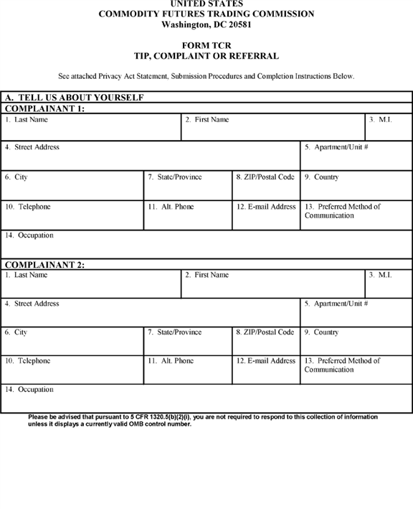

**[*59563]**



**[*59564]**

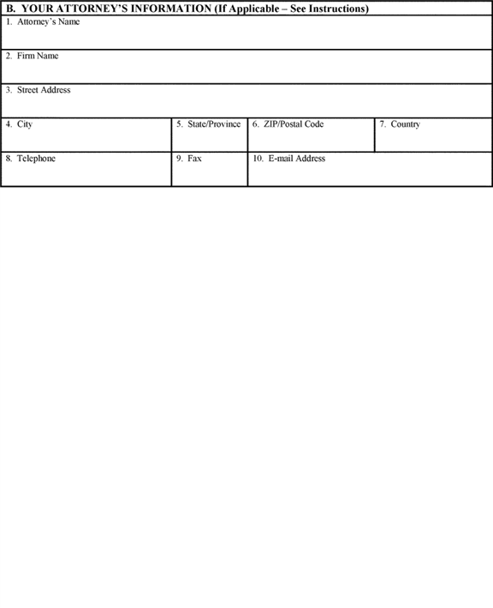

**[*59564]**



**[*59565]**

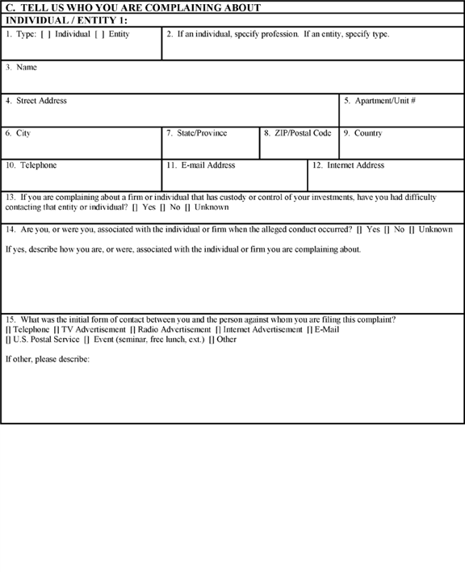

**[*59565]**



**[*59566]**

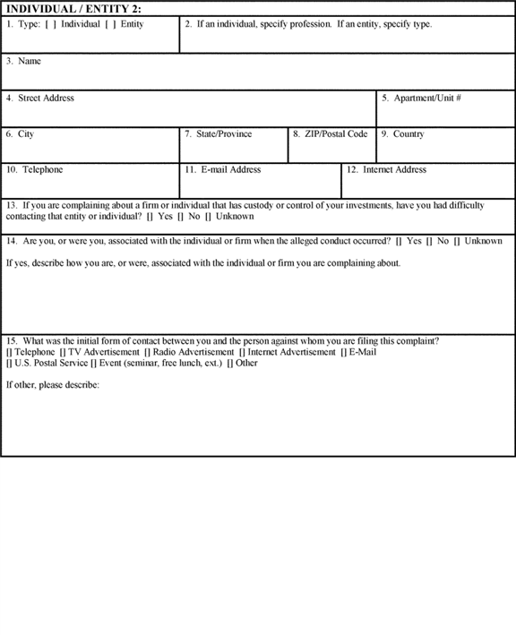

**[*59566]**



**[*59567]**

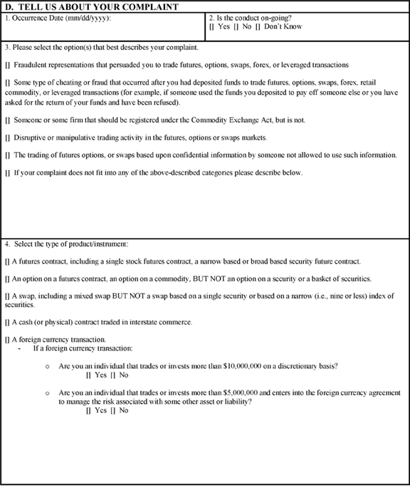

**[*59567]**



**[*59568]**

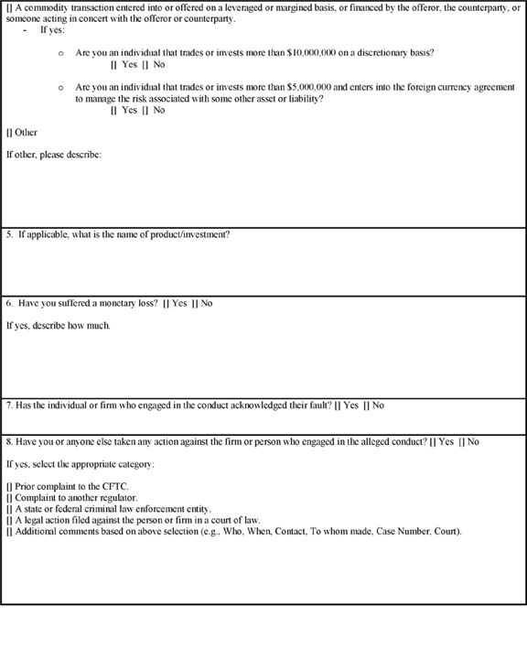

**[*59568]**



**[*59569]**

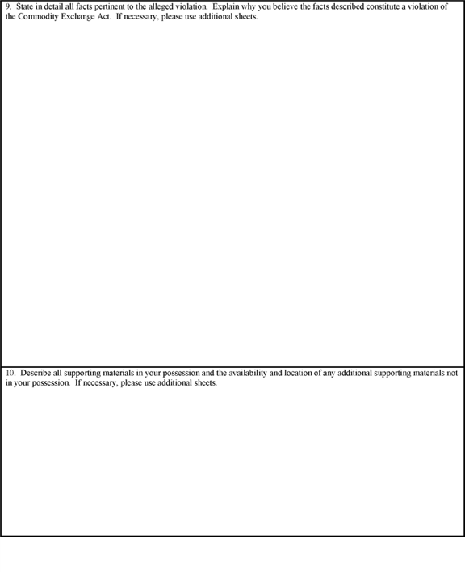

**[*59569]**



**[*59570]**

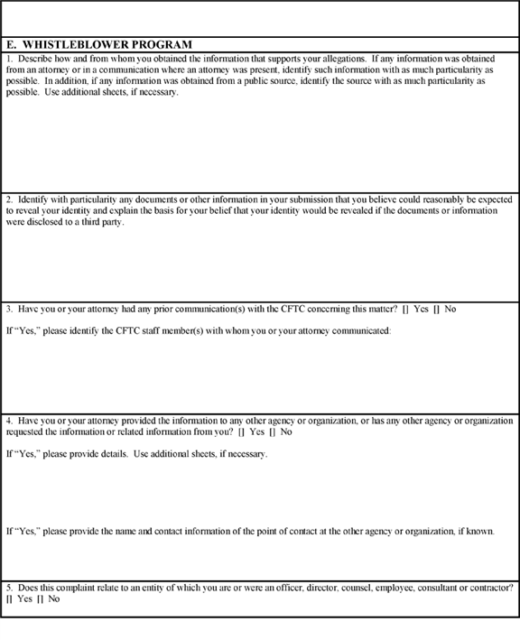

**[*59570]**



**[*59571]**

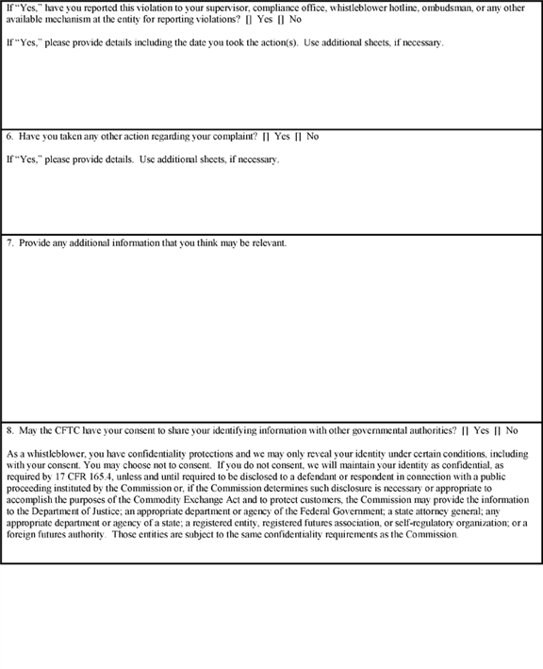

**[*59571]**



**[*59572]**

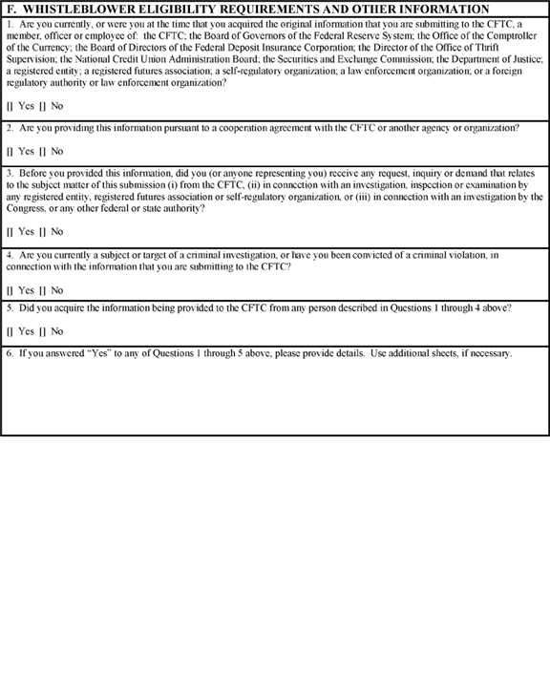

**[*59572]**



**[*59573]**

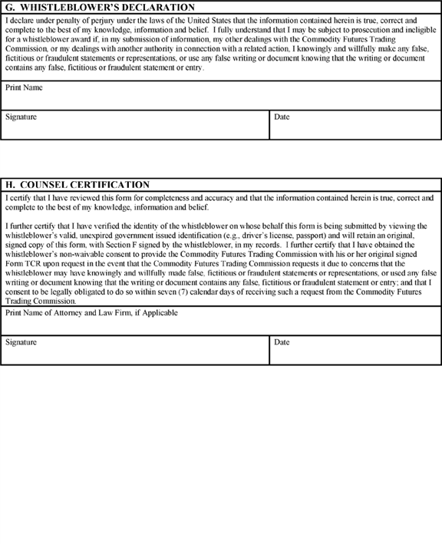

**[*59573]**



BILLING CODE 6351-01-C

**Privacy Act Statement**

This notice is given under the Privacy Act of 1974. The Privacy Act requires that the Commodity Futures Trading Commission (CFTC) inform individuals of the following when asking for information. The solicitation of this information is authorized under the Commodity Exchange Act, [*7 U.S.C. 1*](https://advance.lexis.com/api/document?collection=statutes-legislation&id=urn:contentItem:4YF7-GRC1-NRF4-427C-00000-00&context=) *et seq.* This form may be used by anyone wishing to provide the CFTC with information concerning a violation of the Commodity Exchange Act or the CFTC's ***regulations***. If an individual is submitting this information for the CFTC's whistleblower award program pursuant to Section 23 of the Commodity Exchange Act, the information provided will be used to enable the CFTC to determine the individual's eligibility for payment of an award. This information will be used to investigate and prosecute violations of the Commodity Exchange Act and the CFTC's ***regulations***. This information may be disclosed to federal, state, local or foreign agencies or other authorities responsible for investigating, prosecuting, enforcing or implementing laws, rules or ***regulations*** implicated by the information consistent with the confidentiality requirements set forth in Section 23 of the Commodity Exchange Act and Part 165 of the CFTC's ***regulations***. The information will be maintained and additional disclosures may be made in accordance with System of Records Notices CFTC-49, "Whistleblower Records" (exempted), CFTC-10, "Investigatory Records" (exempted), and CFTC-16, "Enforcement Case Files." Furnishing the information is voluntary. However, if an individual is providing information for the whistleblower award program, not providing required information may result in the individual not being eligible for award consideration.

Questions concerning this form may be directed to Commodity Futures Trading Commission, Whistleblower Office, Three Lafayette Centre, 1155 21st Street NW., Washington, DC 20581.

**Submission Procedures**

* If you are submitting information for the CFTC's whistleblower award program, you *must* submit your information using this Form TCR.

1. You may submit this form electronically, through the web portal found on the CFTC's Web site at [*http://www.cftc.gov*](http://www.cftc.gov)*,* which is also accessible from the CFTC Whistleblower Program Web site at [*www.whistleblower.gov*](http://www.whistleblower.gov)*.* You may also print this form and submit it by mail to Commodity Futures Trading Commission, Whistleblower Office, Three Lafayette Centre, 1155 21st Street NW., Washington, DC 20581, or by facsimile to (202) 418-5975.
2. You have the right to submit information anonymously. If you do not submit anonymously, please note that the CFTC is required by law to maintain the confidentiality of any information which could reasonably identify you, and will only reveal such information in limited and specifically-defined circumstances. *See* [*7 U.S.C. 26(h)(2)*](https://advance.lexis.com/api/document?collection=statutes-legislation&id=urn:contentItem:4YF7-GT91-NRF4-40PG-00000-00&context=); [*17 CFR 165.4*](https://advance.lexis.com/api/document?collection=administrative-codes&id=urn:contentItem:5R5D-0TM0-008G-Y23B-00000-00&context=). However, in order to receive a whistleblower award, you will need to be identified to select CFTC staff for a final eligibility determination, and in unusual circumstances, you may need to be identified publicly for trial. You should therefore provide some means for the CFTC's staff to contact you, such as a telephone number or an email address.

**Instructions for Completing Form TCR**

**General**

All references to "you" and "your" are intended to mean the complainant.

1. **elf**

Questions 1-14: Please provide the following information about yourself:

[] last name, first name and middle initial;

[] complete address, including city, state and zip code;

[] telephone number and, if available, an alternate number where you can be reached;

[] your email address (to facilitate communications, we strongly encourage you to provide an email address, especially if you are filing anonymously);

[] your preferred method of communication; and

[] your occupation.

1. **ormation**

Complete this section only if you are represented by an attorney in this matter.

Questions 1-10: Provide the following information about your attorney:

[] attorney's name;

[] firm name;

[] complete address, including city, state and zip code;

[] telephone number and fax number; and

[] email address.

1. **Complaining About**

Question 1-2: Choose one of the following that best describes the individual's profession or the type of entity to which your complaint relates:

For Individuals: accountant, analyst, associated person, attorney, auditor, broker, commodity trading advisor, commodity pool operator, compliance officer, employee, executing broker, executive officer or director, financial planner, floor broker, floor trader, trader, unknown or other (specify).

For Entities: bank, commodity pool, commodity pool operator, commodity trading advisor, futures commission merchant, hedge fund, introducing broker, major swap participant, retail foreign exchange dealer, swap dealer, unknown or other (specify).

Questions 3-12: For each individual and/or entity, provide the following information, if known:

[] full name;

[] complete address, including city, state and zip code;

[] telephone number;

[] email address; and

[] internet address, if applicable.

Questions 13: If the firm or individual you are complaining about has custody or control of your investment, identify whether you have had difficulty contacting that firm or individual.

Question 14: Identify if you are, or were, associated with the individual or firm you are complaining about. If yes, describe how you are, or were, associated with the individual or firm you are complaining about.

Question 15: Identify the initial form of contact between you and the person against whom you are filing this complaint.

1. **Complaint**

Question 1: State the date (mm/dd/yyyy) that the alleged conduct occurred or began.

Question 2: Identify if the conduct is on-going.

Question 3: Choose the option that you believe best describes the nature of your complaint. If you are alleging more than one violation, please list all that you believe may apply.

Question 4: Select the type of product or instrument you are complaining about.

Question 5: If applicable, please name the product or instrument. If yes, please describe.

Question 6: Identify whether you have suffered a monetary loss. If yes, please describe.

Question 7: Identify if the individual or firm you are complaining about acknowledged their fault.

Question 8: Indicate whether you have taken any other action regarding your complaint, including whether you complained to the CFTC, another regulator, a law enforcement agency, or any other agency or organization, or initiated legal action, mediation, arbitration or any other action.

If you answered yes, provide details, including the date on which you took the action(s) described, the name of the person or entity to whom you directed any report or complaint, and contact information for the person or entity, if known, and the complete case name, case number and forum of any legal action you have taken.

Question 9: State in detail all facts pertinent to the alleged violation. Explain why you believe the facts described constitute a violation of the Commodity Exchange Act.

Question 10: Describe all supporting materials in your possession and the availability and location of any additional supporting materials not in your possession.

1. **am**

Question 1: Describe how you obtained the information that supports your allegations. If any information was obtained from an attorney or in a communication where an attorney was present, identify such information with as much particularity as possible. In addition, if any information was obtained from a public source, identify the source with as much particularity as possible.

Question 2: Identify any documents or other information in your submission on this Form TCR that you believe could reasonably be expected to reveal your identity. Explain the basis for your belief that your identity would be revealed if the documents or information were disclosed to a third party.

Question 3: State whether you or your attorney have had any prior **[*59574]** communication(s) with the CFTC concerning this matter.

If you answered "yes", identify the CFTC staff member(s) with whom you or your attorney communicated.

Question 4: Indicate whether you or your attorney have provided the information you are providing to the CFTC to any other agency or organization, or whether any other agency or organization has requested the information or related information from you.

If you answered "yes", provide details and the name and contact information of the point of contact at the other agency or organization, if known.

Question 5: Indicate whether your complaint relates to an entity of which you are, or were in the past, an officer, director, counsel, employee, consultant or contractor.

If you answered "yes", state whether you have reported this violation to your supervisor, compliance office, whistleblower hotline, ombudsman, or any other available mechanism at the entity for reporting violations. Please provide details, including the date on which you took the action.

Question 6: Indicate whether you have taken any other action regarding your complaint, including whether you complained to the CFTC, another regulator, a law enforcement agency, or any other agency or organization, or initiated legal action, mediation, arbitration or any other action.

If you answered "yes", provide details, including the date on which you took the action(s) described, the name of the person or entity to whom you directed any report or complaint, and contact information for the person or entity, if known, and the complete case name, case number and forum of any legal action you have taken.

Question 7: Provide any additional information you think may be relevant.

Question 8: Indicate whether you provide your consent to the CFTC allowing the CFTC to share your identifying information with other governmental authorities.

1. **bility Requirements and Other Information**

Question 1: State whether you are currently, or were at the time that you acquired the original information that you are submitting to the CFTC, a member, officer or employee of: the CFTC; the Board of Governors of the Federal Reserve System; the Office of the Comptroller of the Currency; the Board of Directors of the Federal Deposit Insurance Corporation; the Director of the Office of Thrift Supervision; the National Credit Union Administration Board; the Securities and Exchange Commission; the Department of Justice; a registered entity; a registered futures association; a self-regulatory organization; a law enforcement organization; or a foreign regulatory authority or law enforcement organization.

Question 2: State whether you are providing the information pursuant to a cooperation agreement with the CFTC or with another agency or organization.

Question 3: State whether you are providing this information before you (or anyone representing you) received any request, inquiry or demand that relates to the subject matter of this submission (i) from the CFTC, (ii) in connection with an investigation, inspection or examination by any registered entity, registered futures association or self-regulatory organization, or (iii) in connection with an investigation by the Congress, or any other federal or state authority.

Question 4: State whether you are currently a subject or target of a criminal investigation, or whether you have been convicted of a criminal violation, in connection with the information you are submitting to the CFTC.

Question 5: State whether you acquired the information you are providing to the CFTC from any individual described in Questions 1 through 4 of this section.

Question 6: If you answered yes to any of Questions 1 through 5, please provide details.

1. **laration**

You must sign this Declaration if you are submitting this information pursuant to the CFTC whistleblower program and wish to be considered for an award. If you are submitting your information using the electronic version of Form TCR through the CFTC's web portal, you must check the box to agree with the declaration. If you are submitting your information anonymously, you must still sign this Declaration (using the term "anonymous") or check the box as appropriate, and, if you are represented by an attorney, you must provide your attorney with the original of this signed form, or maintain a copy for your own records. If you are not submitting your information pursuant to the CFTC whistleblower program, you do not need to sign this Declaration or check the box.

1. **on**

If you are submitting this information pursuant to the CFTC whistleblower program and you are doing so anonymously through an attorney, your attorney must sign the Counsel Certification Section. If your attorney is submitting your information using the electronic version of Form TCR through the CFTC's web portal, he/she must check the box to agree with the certification. If you are represented in this matter but you are not submitting your information pursuant to the CFTC whistleblower program, your attorney does not need to sign this Certification or check the box.

BILLING CODE 6351-01-P **[*59575]**

**[*59576]**

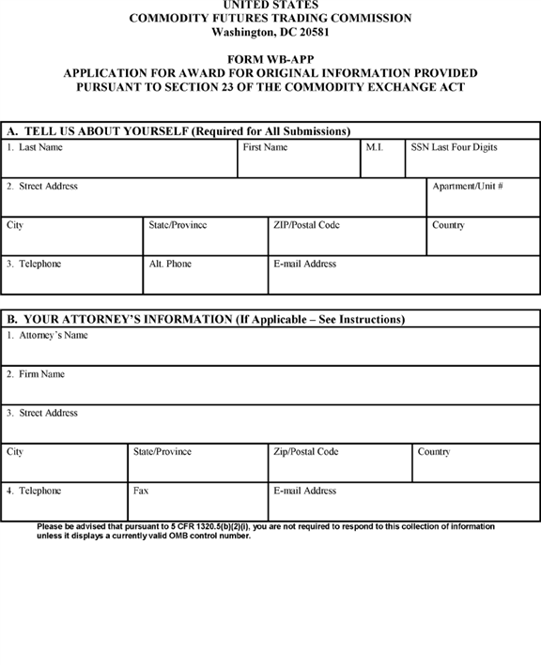

**[*59576]**



**[*59577]**

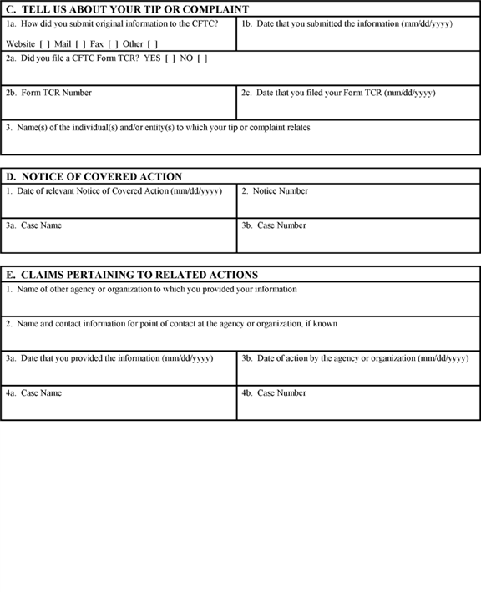

**[*59577]**



**[*59578]**

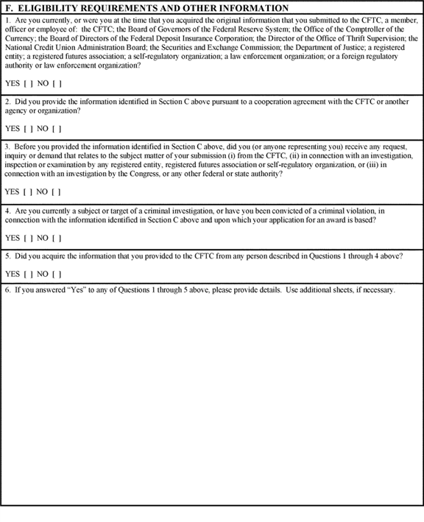

**[*59578]**



**[*59579]**



**[*59579]**



**[*59580]**

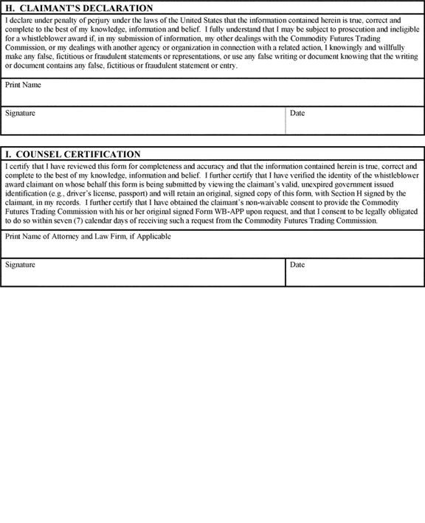

**[*59580]**



BILLING CODE 6351-01-C

**Privacy Act Statement**

This notice is given under the Privacy Act of 1974. The Privacy Act requires that the Commodity Futures Trading Commission (CFTC) inform individuals of the following when asking for information. The solicitation of this information is authorized under the Commodity Exchange Act, [*7 U.S.C. 1*](https://advance.lexis.com/api/document?collection=statutes-legislation&id=urn:contentItem:4YF7-GRC1-NRF4-427C-00000-00&context=) *et seq.* The information provided will enable the CFTC to determine the whistleblower award claimant's eligibility for payment of an award pursuant to Section 23 of the Commodity Exchange Act and Part 165 of the CFTC's ***regulations***. This information will be used to investigate and prosecute violations of the Commodity Exchange Act and the CFTC's ***regulations***. This information may be disclosed to federal, state, local or foreign agencies or other authorities responsible for investigating, prosecuting, enforcing or implementing laws, rules or ***regulations*** implicated by the information consistent with the confidentiality requirements set forth in Section 23 of the Commodity Exchange Act and Part 165 of the CFTC's ***regulations***. The information will be maintained and additional disclosures may be made in accordance with System of Records Notices CFTC-49, "Whistleblower Records" (exempted), CFTC-10, "Investigatory Records" (exempted), and CFTC-16, "Enforcement Case Files." The CFTC requests the last four digits of the claimant's Social Security Number for use as an individual identifier to administer and manage the whistleblower award program. Executive Order 9397 (November 22, 1943) allows federal agencies to use the Social Security Number as an individual identifier. Furnishing the information is voluntary. However, if an individual is providing information for the whistleblower award program, not providing required information may result in the individual not being eligible for award consideration.

Questions concerning this form may be directed to Commodity Futures Trading Commission, Whistleblower Office, Three Lafayette Centre, 1155 21st Street NW., Washington, DC 20581.

**Submission Procedures**

* This form *must* be used by persons making a claim for a whistleblower award in connection with information provided to the CFTC, or to another agency or organization in a related action. In order to be deemed eligible for an award, you must meet all the requirements set forth in Section 23 of the Commodity Exchange Act and Part 165 of the CFTC's ***regulations***.

1. You must sign the Form WB-APP as the claimant. If you wish to submit the Form WB-APP anonymously, you must do so through an attorney, your attorney must sign the Counsel Certification Section of the Form WB-APP that is submitted to the CFTC, and you must give your attorney your original signed Form WB-APP so that it can be produced to the CFTC upon request.
2. During the whistleblower award claim process, your identity must be verified in a form and manner that is acceptable to the CFTC prior to the payment of any award.
3. If you are filing your claim in connection with information that you provided to the CFTC, then your Form WB-APP, and any attachments thereto, must be received by the CFTC within ninety (90) days of the date of the Notice of Covered Action, or the date of a final judgment in a related action to which the claim relates.
4. If you are filing your claim in connection with information that you provided to another agency or organization in a related action, then your Form WB-APP, and any attachments thereto, must be received by the CFTC as follows:
5. If a final order imposing monetary sanctions has been entered in a related action at the time that you submit your claim for an award in connection with a CFTC action, you may submit your claim for an award in that related action on the same Form WB-APP that you use for the CFTC action.
6. If a final order imposing monetary sanctions in a related action has not been entered at the time that you submit your claim for an award in connection with a CFTC action, you must submit your claim on Form WB-APP within ninety (90) days of the issuance of a final order imposing sanctions in the related action.
7. If a final judgment imposing monetary sanctions in a related action has been entered and a Notice of Covered Action for a related covered judicial or administrative action has not been published, you may submit your claims for awards in both the covered judicial or administrative action and related action within ninety (90) days of the date of the Notice of Covered Action. The claims may be submitted on the same Form WB-APP.
8. If a final order imposing monetary sanctions in a related action relates to a judicial or administrative action brought by the Commission under the Commodity Exchange Act that is not a covered judicial or administrative action, and therefore there would not be a Notice of Covered Action, you must submit your claim on Form WB-APP for an award in connection with the related action within ninety (90) calendar days following either (1) the date of issuance of a final order in the related action, if that date is after the date of issuance of the final judgment in the related Commission judicial or administrative action; or (2) the date of issuance of the final judgment in the related Commission judicial or administrative action, *i.e.,* the date the related action becomes a related action, if the date of issuance of the final order in the related action precedes the final judgment in the related Commission judicial or administrative action.
9. To submit your Form WB-APP, you may print it and either submit it by mail to Commodity Futures Trading Commission, Whistleblower Office, Three Lafayette Centre, 1155 21st Street NW., Washington, DC 20581, or by facsimile to (202) 418-5975. You also may submit this form electronically, through the web portal found on the CFTC's Web site at [*http://www.cftc.gov*](http://www.cftc.gov)*,* which is also accessible from the CFTC Whistleblower Program Web site at [*www.whistleblower.gov*](http://www.whistleblower.gov)*.*

**Instructions for Completing Form WB-APP**

**General**

All references to "you" and "your" are intended to mean the whistleblower award claimant.

1. **elf**

Questions 1-3: Please provide the following information about yourself:

* last name, first name, middle initial and the last four digits of your Social Security Number;

1. complete address, including city, state and zip code;
2. telephone number and, if available, an alternate number where you can be reached; and
3. your email address (to facilitate communications, we strongly encourage you to provide an email address, especially if you are making your claim anonymously).
4. **ormation**

Complete this section only if you are represented by an attorney in this matter.

Questions 1-4: Provide the following information about your attorney:

* attorney's name;

1. firm name;
2. complete address, including city, state and zip code;
3. telephone number and fax number; and
4. email address.
5. **Tip or Complaint**

Question 1a: Indicate the manner in which you submitted your original information to the CFTC.

Question 1b: Provide the date on which you submitted your original information to the CFTC.

Question 2a: State whether you filed a CFTC Form TCR.

Question 2b: If you filed a CFTC Form TCR, provide the Form's number.

Question 2c: If you filed a CFTC Form TCR, provide the date on which you filed the Form.

Question 3: Provide the name(s) of the individual(s) and/or entity(s) to which your tip or complaint relates.

1. **ction**

The process for making a claim for a whistleblower award for a CFTC action begins with the publication of a "Notice of Covered Action" on the CFTC's Web site. This Notice is published whenever a judicial or administrative action brought by the CFTC results in the imposition of monetary sanctions exceeding $ 1,000,000. The Notice is published on the CFTC's Web site subsequent to the entry of a final judgment or order in the action that by itself, or collectively with other judgments or orders previously entered in the action, exceeds the $ 1,000,000 threshold required for a whistleblower to be potentially eligible for an award. The CFTC will not contact whistleblower claimants directly as to Notices of Covered Actions; prospective claimants should monitor the CFTC Web site for such Notices. **[*59581]**

Question 1: Provide the date of the Notice of Covered Action to which this claim relates.

Question 2: Provide the notice number of the Notice of Covered Action.

Question 3a: Provide the case name referenced in the Notice of Covered Action.

Question 3b: Provide the case number referenced in the Notice of Covered Action.

1. **o Related Actions**

Question 1: Provide the name of the agency or organization to which you provided your information.

Question 2: Provide the name and contact information for your point of contact at the agency or organization, if known.

Question 3a: Provide the date on which you provided your information to the agency or organization referenced in Question 1 of this section.

Question 3b: Provide the date on which the agency or organization referenced in Question 1 of this section filed the related action that was based upon the information that you provided.

Question 4a: Provide the case name of the related action.

Question 4b: Provide the case number of the related action.

1. **ments and Other Information**

Question 1: State whether you are currently, or were at the time that you acquired the original information that you submitted to the CFTC, a member, officer or employee of: the CFTC; the Board of Governors of the Federal Reserve System; the Office of the Comptroller of the Currency; the Board of Directors of the Federal Deposit Insurance Corporation; the Director of the Office of Thrift Supervision; the National Credit Union Administration Board; the Securities and Exchange Commission; the Department of Justice; a registered entity; a registered futures association; a self-regulatory organization; a law enforcement organization; or a foreign regulatory authority or law enforcement organization.

Question 2: State whether you provided the information that you submitted to the CFTC pursuant to a cooperation agreement with the CFTC, or with any other agency or organization.

Question 3: State whether you provided this information before you (or anyone representing you) received any request, inquiry or demand that relates to the subject matter of your submission (i) from the CFTC, (ii) in connection with an investigation, inspection or examination by any registered entity, registered futures association or self-regulatory organization, or (iii) in connection with an investigation by the Congress, or any other federal or state authority.

Question 4: State whether you are currently a subject or target of a criminal investigation, or whether you have been convicted of a criminal violation, in connection with the information that you submitted to the CFTC and upon which your application for an award is based.

Question 5: State whether you acquired the information that you provided to the CFTC from any individual described in Questions 1 through 4 of this section.

Question 6: If you answered yes to any of Questions 1 through 5 of this section, please provide details.

1. **d**

This section is optional. Use this section to explain the basis for your belief that you are entitled to an award in connection with your submission of information to the CFTC, or to another agency in connection with a related action. Specifically, address why you believe that you voluntarily provided the CFTC with original information that led to the successful enforcement of a judicial or administrative action filed by the CFTC, or a related action. Refer to § 165.9 of Part 165 of the CFTC's ***regulations*** for further information concerning the relevant award criteria.

Section 23(c)(1)(B) of the Commodity Exchange Act and § 165.9(a) of Part 165 of the CFTC's ***regulations*** require the CFTC to consider the following factors in determining the amount of an award: (1) the significance of the information provided by a whistleblower to the success of the CFTC action or related action; (2) the degree of assistance provided by the whistleblower and any legal representative of the whistleblower in the CFTC action or related action; (3) the programmatic interest of the CFTC in deterring violations of the Commodity Exchange Act (including ***regulations*** under the Act) by making awards to whistleblowers who provide information that leads to the successful enforcement of such laws; (4) whether the award otherwise enhances the CFTC's ability to enforce the Commodity Exchange Act, protect customers, and encourage the submission of high quality information from whistleblowers; and (5) potential adverse incentives from oversize awards. Address these factors in your response as well.

1. **ion**

You must sign this Declaration if you are submitting this claim pursuant to the CFTC whistleblower program and wish to be considered for an award. If you are submitting your claim anonymously, you must do so through an attorney, and you must provide your attorney with your original signed Form WB-APP.

1. **on**

If you are submitting this claim pursuant to the CFTC whistleblower program anonymously, you must do so through an attorney, and your attorney must sign the Counsel Certification Section.

Issued in Washington, DC, on August 24, 2016, by the Commission.

**Christopher J. Kirkpatrick,**

*Secretary of the Commission.*

**Note:** The following appendix will not appear in the Code of Federal ***Regulations***.

**Appendix to Whistleblower Awards Process--Commission Voting Summary**

On this matter, Chairman Massad and Commissioners Bowen and Giancarlo voted in the affirmative. No Commissioner voted in the negative.

[FR Doc. 2016-20745 Filed 8-29-16; 8:45 am]

BILLING CODE 6351-01-P

**Dates**

**DATES:** Comments must be received on or before September 29, 2016. **[*59552]**

**Contacts**

**ADDRESSES:** You may submit comments, identified by RIN 3038-AE50, by any of the following methods:

* *CFTC Web site:* [*http://comments.cftc.gov*](http://comments.cftc.gov)*.* Follow the instructions for submitting comments through the Comments Online process on the Web site.

1. *Mail:* Send to Christopher Kirkpatrick, Secretary of the Commission, Commodity Futures Trading Commission, Three Lafayette Centre, 1155 21st Street NW., Washington, DC 20581.
2. *Hand Delivery/Courier:* Same as Mail, above.
3. *Federal eRulemaking Portal:* [*http://www.****regulations****.gov*](http://www.regulations.gov)*.* Follow the instructions for submitting comments.

Please submit your comments using only one of these methods.

All comments must be submitted in English, or if not, accompanied by an English translation. Comments will be posted as received to [*www.cftc.gov*](http://www.cftc.gov)*.* You should submit only information that you wish to make available publicly. If you wish the Commission to consider information that is exempt from disclosure under the Freedom of Information Act ("FOIA"), a petition for confidential treatment of the exempt information may be submitted according to the procedure established in § 145.9 of the Commission's FOIA ***regulations*** (17 CFR 145.9).

The Commission reserves the right, but shall have no obligation, to review, pre-screen, filter, redact, refuse, or remove any or all of your submission from [*www.cftc.gov*](http://www.cftc.gov) that it may deem to be inappropriate for publication, such as obscene language. All submissions that have been redacted or removed that contain comments on the merits of the rulemaking will be retained in the public comment file and will be considered as required under the Administrative Procedure Act and other applicable laws, and may be accessible under the FOIA.

**FOR FURTHER INFORMATION CONTACT:** Anthony Hays, Counsel, (202) 418-5584, [*ahays@cftc.gov*](mailto:ahays@cftc.gov)*,* Commodity Futures Trading Commission, Three Lafayette Centre, 1155 21st Street NW., Washington, DC 20581.

FEDERAL REGISTER

**End of Document**